Lady Warriors Women’s Soccer Spring/Summer 2020 Training Manual

Lady Warriors Soccer,

Welcome to the 2020 season. As we begin this new season, we are beginning it with the most uncertainty that any of us have experienced in our lifetime. Unfortunately, none of us know what to expect moving forward and all we can do is prepare ourselves as best we can to be ready when we’re allowed to do so.

It is imperative, more so this year than any other year, that each of you begin the process of physically preparing yourselves for the upcoming season. There is a distinct possibility that our summer workout schedule will be cut somewhat, or eliminated all together, so if the state allows us to begin practice on August 17th, we must be ready to go. We can’t take the normal tryout week to get ourselves in shape, we must come into the preseason physically ready to go, and have our main focus be about soccer.

This individualized workout program has been designed to help each and every one of you accomplish our fitness goals. I’ve tried to make the program as easy to follow as possible, and I’ve also allowed for flexibility in doing your workouts. As the program was put together, I want you to please be aware of the following:
- Even though some of you have indicated to me that you’ve been working out, this has been designed with the mind set that very little physical activity has been done since the shutdown. You will see, especially with the distance runs, things start out fairly light, and gradually progress throughout.
- With limited use of fields, you’ll notice that Phase I & II can all be done without the use of a field. Hopefully as restrictions loosen, fields will become available to everyone and workouts can transition to them.
- On the schedule, you’ll notice that the headings underneath each phase are workout 1, workout 2 and workout 3. You can do the workouts on any 3 days you’d like, and you can do the workouts in any order. You do not have to follow the pattern on the chart, for example if you wanted to do your distance run last in the week, you could. You have the flexibility to choose what workout you want to do on each day.
- With that being said, I highly recommend you don’t do the workouts on 3 consecutive days. Rest and recovery is important, so make sure you’re allowing for that. A suggestion might be Monday’s, Wednesday’s and Friday’s, but that is up to you.
-Finally, if we should be able to have our summer workouts, we will continue to follow the schedule given in the packet.

The teams that prepare the best on their own, will be the most successful in 2020. With so much uncertainty, there’s no doubt in my mind this will be the case. I firmly believe this program will give us a great chance to succeed when we’re ready to play. Our issue will be, how many of us are going to do this each week? Do you have the motivation to do this on your own? I can tell you, if we have 20 players in the program doing this, 2020 will not be the season you’re hoping for. In order for us to be the top level program we strive to be, we need as close to 100% participation as possible. This is a program designed for every level of Lady Warriors Soccer, and the expectation is for every player to participate and get themselves ready for the season. Work hard, push & challenge yourselves, and I hope to see everyone very soon on the field.

Coach Fig

Week #1

Sprint Workout

Fartlek #1 - 40 minutes in duration
- 2 minutes - walk 15 seconds, jog 45 seconds
- 3 minutes - walk 15 seconds, stride 45 seconds….stride(75% sprint)
- 15 minutes - walk 45 seconds, sprint 15 seconds
- 2 minutes - walk 15 seconds, jog 45 seconds
- 3 minutes - walk 15 seconds, stride 45 seconds
- 10 minutes - walk 40 seconds, sprint 20 seconds
- 5 minutes – jog

Ball Work
MSU #1 - 10 exercises...first one should be done for 30 seconds without mistake before moving on to the next. https://www.youtube.com/watch?v=fKCvB6rAxQc

Body Weight Circuit

Warriors Body Weight Circuit

TO BE COMPLETED TWICE!!
Exercise | Durations
Squats | 20 reps
Tricep Dip | 20 reps
Abs(90 degree crunch) | 90 seconds
Split Squat Jump(Split Squat Jump(lunge position; one leg out in front, explode off front leg into the air) | 20 reps
Elevated Pushups | 20 reps
Abs(plank) | 90 seconds
Alternating Front Lunge | 20 reps
Diamond Push Ups | 20 reps
Abs(reverse crunch) | 90 seconds
Squat Jumps | 20 reps
Push Ups | 20 reps
Abs;Butterfly Crunch(soles of feet together, regular crunch from that position) | 90 seconds

Week #2

Sprint Workout

Interval Run #1 - 20 minutes in duration

- 0-5:00 - Jog
- 5:00-15:00 - 30 second sprint/ 30 second jog
- 15:00-16:00 - Jog
- 16:00 - 20:00 - 1:00 Hard run/ 1:00 Jog

Ball Work
MSU #2
https://www.youtube.com/watch?v=DBZnUBNqNu4

1 minute of each
Single foot cuts – Right
Single Foot cuts – Left
Roll to cut – Right
Roll to Cut – Left
2 Footed Cuts
Tap tap roll
Tab Ramos Combo
Tab Ramos Combo other way
V – Inside
V – Outside
V – Behind the back – right
V – Behind the back – Left
Scissors – outside
Stepover – outside

Body Weight Circuit

Roadrunner Body Circuit - each exercise is to be performed for 45 seconds; 30 second rest between each exercise. Do 2 rotations of the assigned body circuit with a 3 minute rest in between circuits

- Squat Lunge
- Lunges - alternate legs
- Bicycle Crunches - hands behind head, legs off ground, opposite elbow to knee
- Pushups
- Broad Jumps - jump as far out as you can
- Bench Dips - hands on a bench or chair, feet straight out on the floor, lower yourself until upper arm is parallel to the floor
- Burpees
- Spiderman Pushups - as you lower yourself, rotate one of your hips out and bring knee to elbow in a bottom position of push up. As you push up the leg goes back to a starting position and repeat with other leg
- Hip Ups - lie on your back, legs straight up in the air, press your hips towards the sky
- Bicycle Jumps - right foot in front, left foot back, jump as high as possible and alternate feet

Week #3

Sprint Workout

Fartlek #3 - 45 minutes in duration
- 2 minutes - walk 20 seconds, jog 40 seconds
- 3 minutes - walk 20 seconds, stride 40 seconds
- 10 minutes - walk 30 seconds, sprint 30 seconds
- 5 minutes - walk 20 seconds, stride 40 seconds
- 5 minutes - walk 30 seconds, sprint 30 seconds
- 5 minutes - walk 20 seconds, jog 40 seconds
- 10 minutes - walk 30 seconds, sprint 30 seconds
- 5 minutes - jog

Ball Work

MSU #3 - Ball work:
https://www.youtube.com/watch?v=yRnRYHPKKcQ

1 minute of each x 3 rounds
- Inside Outside
- Inside Inside
- Sole Outside
- Sole Inside
- Behind Standing Leg Outside
- Behind Standing Leg Inside

Body Weight Circuit

WH #1

Pre- Set -- 3 rounds
- 5 push ups
- 15 air squats
- Reverse lunges 5 each leg

Then

10 Push-ups
20 Plyo Squats https://www.youtube.com/watch?v=SDJIQq-BrCc
30 Ski Abs https://www.youtube.com/watch?v=cgbvMWTBqW4
10 Single Leg RDL to high knee https://www.youtube.com/watch?v=S96eoqwdZ7o&feature=youtu.be

Week #4

Sprint Workout

Interval Run #2 - 30 minutes in duration

Jog for 60 seconds / Sprint for 30 seconds / Walk for 30 seconds = 2 minutes(Repeat for 30 minutes)

Ball Work

MSU #4
https://www.youtube.com/watch?v=7QEflsYZp3M

Inside Push
Outside Push
Inside Fwd Push
Inside Push Sole roll
L Drag
Alternate V Cuts
Parallel Sole Rolls
Sole Push & Pull
Single Leg Square
Double Leg Square

Body Weight Circuit

WH #2
Pre- Set -- 3 rounds
10 lunges
20 slow Everest climbers (step, not jump) https://www.youtube.com/watch?v=uiF0ghf6nGs
30 Jumping jacks

4 rounds …. 45 seconds on, 15 seconds off
(ROUND 1 -- 45 seconds of high knees, rest 15, 45 seconds of Everest climbers, rest 15, 45 seconds of Burpees, rest 15, 45 seconds of V-ups, rest 15)
High knees https://www.youtube.com/watch?v=DfjpR6dzLVg
Everest Climbers (fast) https://www.youtube.com/watch?v=uiF0ghf6nGs
Burpees
V-ups https://www.youtube.com/watch?v=t6OC23JDQLU

Week #5

Sprint Workout

Redhawk Sprint Series #4

Sprint (seconds) | Jog (seconds)
0 | 60
10 | 50
20 | 40
30 | 30
40 | 20
50 | 10
40 | 20
30 | 30
20 | 40
10 | 50
0 | 60

Ball Work

MSU #5 (1 minute of each) https://www.youtube.com/watch?v=Zn5HWMIxQsQ&t=31s
Inside R
Inside L
Inside both
Laces R
Laces L
Laces Both
2 touch R
2 Touch Left
2 touch Inside opening up
2 touch inside across body
2 touch Outside, Inside

Body Weight Circuit

WH #3
Pre- Set -- 3 rounds
10 lunges
20 slow Everest climbers (step, not jump) https://www.youtube.com/watch?v=uiF0ghf6nGs
30 Jumping jacks

5 rounds …. Try to complete as fast as possible
HR Push-ups x 10
Burpees x 15
Fingertip crunches x 20 https://www.youtube.com/watch?v=nTvzj67hbpo
Air Squats x 30

Week #6

Sprint Workout

5-10-15-20-25yd Shuttle (10 reps with a 1:30 rest in between each rep)

This is a shuttle drill, meaning you will be running back and forth (changing direction). From your starting line walk out 5yds, 10yds, 15yds, 20yds, and 25 yds
Sprint from the start to 5yds planting your foot at the cone, and then sprint back
Sprint from the start to 10yds and back
Sprint from the start to 15 yds and back
Sprint from the start to 20yds and back
Sprint from the start to 25yds and back through the finish
This is one rep

Ball Work

MSU #1 - 10 exercises...first one should be done for 30 seconds without mistake before moving on to the next. https://www.youtube.com/watch?v=fKCvB6rAxQc

Body Weight Circuit
WH #4
Work-out:

Pre- Set -- 3 rounds … Slow deliberate perfect reps, form is important, time is not
Single Leg RDL X 8 each leg - https://www.youtube.com/watch?v=FujJkRLG1Fg
Single Leg hip thrusters x 10 each leg https://www.youtube.com/watch?v=om7q9aCVvR0
Super-womans x 3 reps of :15 seconds. https://www.youtube.com/watch?v=z6PJMT2y8GQ

Set a timer for 20 minutes. Do each exercise in order for the prescribed number of reps, when you complete Russian Twists, start again at Burpees. While we are striving for good form, our focus is on the intensity of the workout.

Burpees x 10 https://www.youtube.com/watch?v=dZgVxmf6jkA
Ski abs x 20 https://www.youtube.com/watch?v=bbK8Tby0N1o
Plyo lunges x 30 https://www.youtube.com/watch?v=sN1F4NBZIik
Oblique V-ups x 40 (20 each side) https://www.youtube.com/watch?v=KnuEA07PYsI
Russian Twists x 50 https://www.youtube.com/watch?v=wkD8rjkodUI

Week #7

Sprint Workout

20/40/60/80s - Set up a cone/disc for 20, 40 ,60, and 80 yards. Sprint to the marker, get a full recovery at the line and sprint back. Each sprint counts as 1 rep. Rest should be no longer than 20 seconds. Goal times...20s - 4 seconds… 40s - 6 seconds...60s - 9 seconds... 80s - 13 seconds

- 1 round trip count as 2 reps
  - 6 reps at each marker for a total of 24 sprints

Ball Work

MSU #2
https://www.youtube.com/watch?v=DBZnUBNqNu4

1 minute of each
Single foot cuts – Right
Single Foot cuts – Left
Roll to cut – Right
Roll to Cut – Left
2 Footed Cuts
Tap tap roll
Tab Ramos Combo
Tab Ramos Combo other way
V – Inside
V – Outside
V – Behind the back – right
V – Behind the back – Left
Scissors – outside
Stepover – outside

Body Weight Circuit

WH #5
Pre- Set -- 3 rounds … Slow deliberate perfect reps, form is important, time is not
Air squats x 10
Lunges x 10
Jane Fondas x 5 each side https://www.youtube.com/watch?v=blVmPUbM58A GREAT FORM IS CRUCIAL

5 rounds of: While we are striving for good form, our focus is on the intensity of the workout.
Wall sit x :30 seconds
Frog Squats x 10 https://www.youtube.com/watch?v=GC2u30Eqj2E
Side lunges x 20 total, 10 each way https://www.youtube.com/watch?v=rvqLVxYqEvo
Jump Squats x 25 https://www.youtube.com/watch?v=0LGJZqKfpXs
Calf raises x 30 https://www.youtube.com/watch?v=UV8gOrHmuKc

WEEK #8

Sprint Workout

Phoenix Sprint #2 (30 second rest)

- 12, 40 yd sprints
- 6 Width of the 18 yd box sprints

Ball Work
MSU #3
https://www.youtube.com/watch?v=yRnRYHPKKcQ

1 minute of each x 3 rounds
- Inside Outside
- Inside Inside
- Sole Outside
- Sole Inside
- Behind Standing Leg Outside
- Behind Standing Leg Inside

Body Weight Circuit

Watchung Hills #1 - 25 reps each
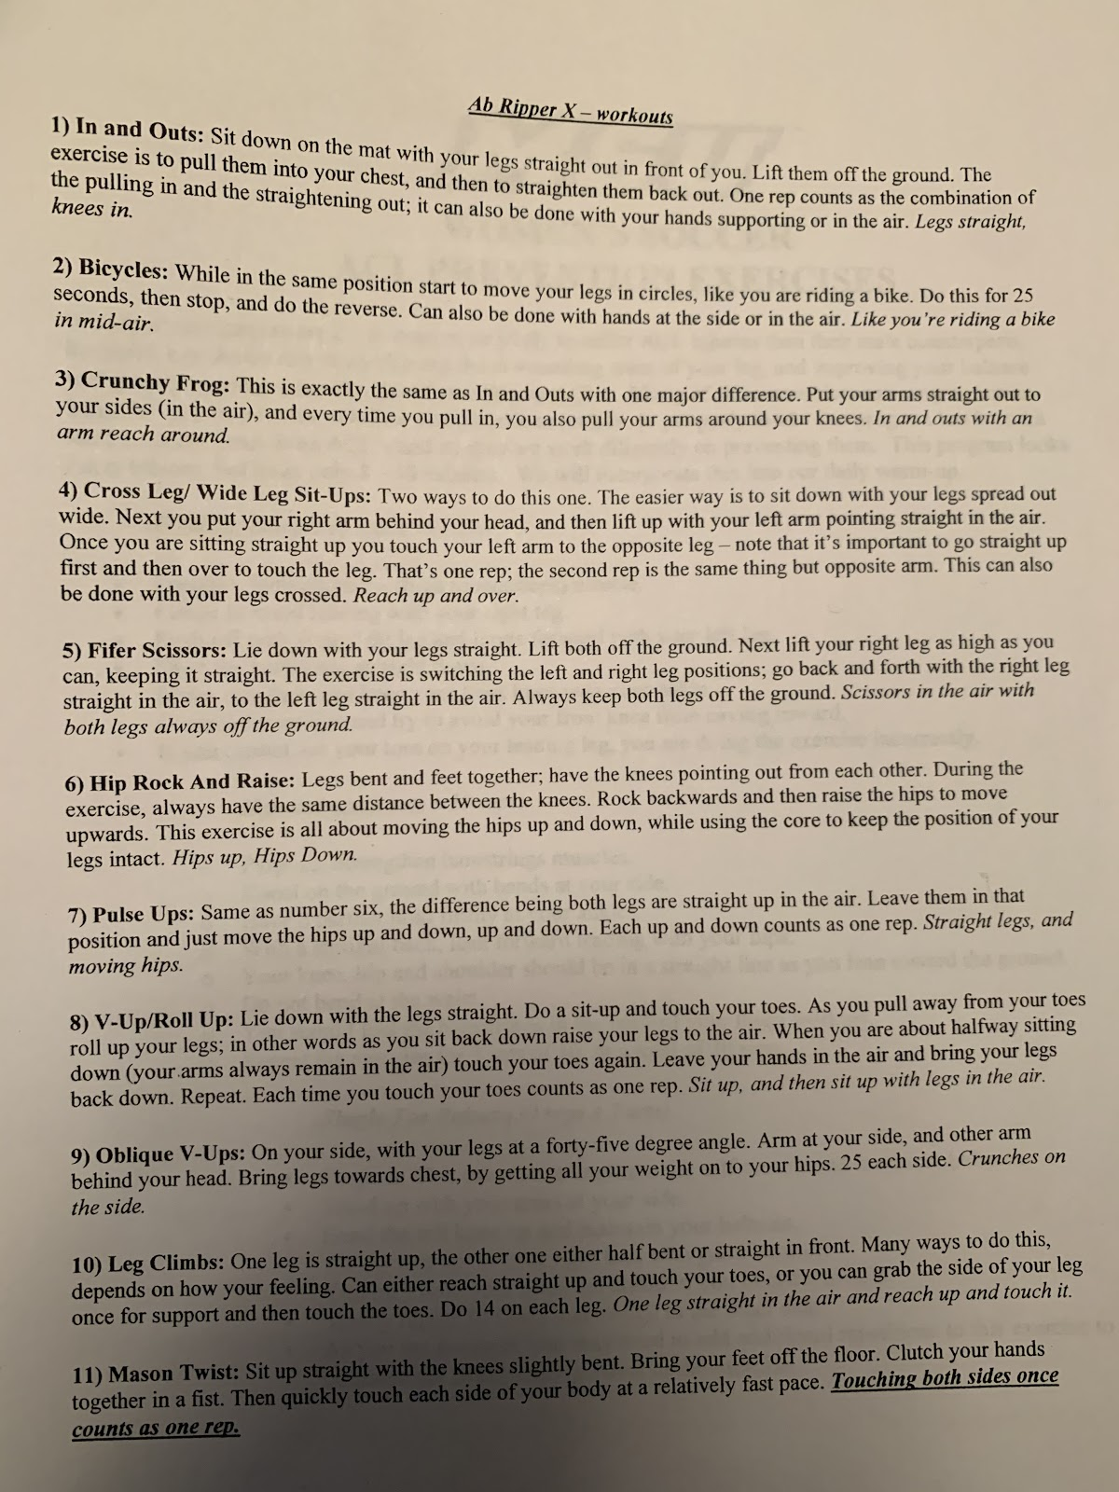

Week #9

Sprint Workout

Redhawk Sprint Series #2

1 length should be roughly the width of a field, or 2 telephone poles.
Sprint 1 Length, rest 30 seconds
Sprint 2 Lengths, rest 30 seconds
Sprint 3 Lengths, rest 30 seconds
Sprint 4 Lengths, rest 30 seconds
Sprint 3 Lengths, rest 30 seconds
Sprint 2 Lengths, rest 30 seconds
Sprint 1 Lengths, rest 30 seconds

Ball Work

MSU #4
https://www.youtube.com/watch?v=7QEflsYZp3M

Inside Push
Outside Push
Inside Fwd Push
Inside Push Sole roll
L Drag
Alternate V Cuts
Parallel Sole Rolls
Sole Push & Pull
Single Leg Square
Double Leg Square

Body Weight Circuit

Watchung Hills #2 - 20 reps for each exercise. Circuit should be completed twice
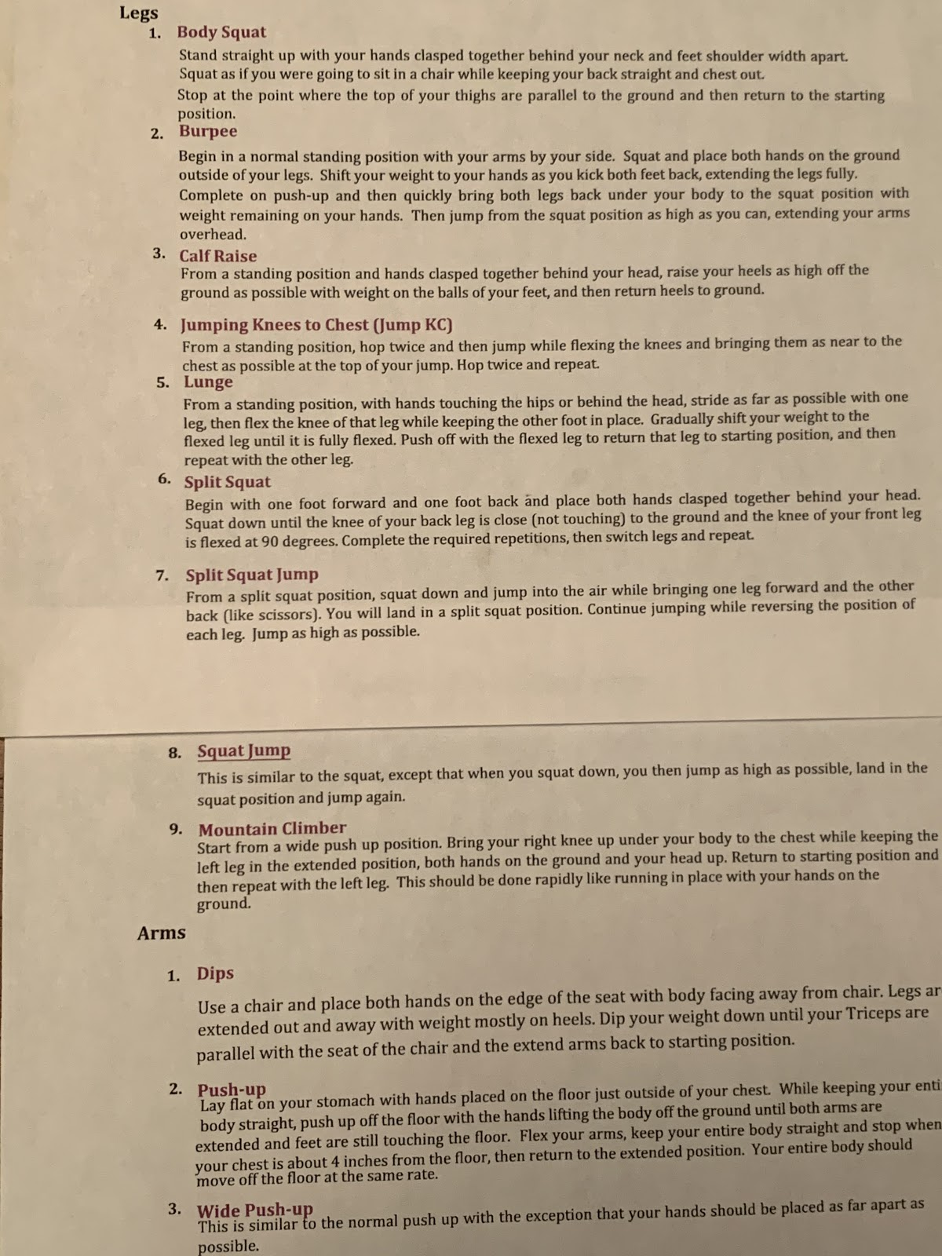

Week #10

Sprint Workout

300 yd Shuttle Runs (3 sets)
- Set up a 50 yd marker(disc or cone)
- Shuttles consist of running to a 50yd marker and back 3 times as fast as possible(this is one set)
- 1 minute rest between each
- Looking for 3 shuttles under 60 seconds

OR

300 yd Shuttle Runs (3 sets)
- Set up a 25 yd marker(disc or cone)
- Shuttles consist of running to a 25yd marker and back 6 times as fast as possible(this is one set)
- 1 minute rest between each
- Looking for 6 shuttles under 60 seconds

Ball Work

MSU #5 (1 minute of each) https://www.youtube.com/watch?v=Zn5HWMIxQsQ&t=31s
Inside R
Inside L
Inside both
Laces R
Laces L
Laces Both
2 touch R
2 Touch Left
2 touch Inside opening up
2 touch inside across body
2 touch Outside, Inside

Body Weight Circuit

Watchung Hills #3 - 2 sets of 20 reps for each exercise

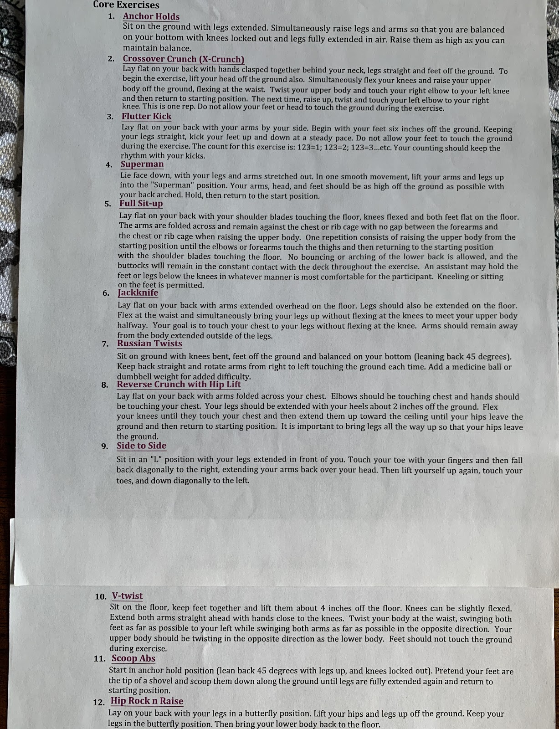

Week #11

Sprint Workout

Split 150s (6 sets)
- Set up a cone at 0, 50, and 100 yds
- Sprint to the 100yd cone in 14 seconds
- Take a 10 second rest
- Sprint back to the 50yd cone in 7 seconds
- After the 50yd sprint, you have 1 minute to get back to the start
- This is 1 set

Ball Work

MSU #1 - 10 exercises...first one should be done for 30 seconds without mistake before moving on to the next. https://www.youtube.com/watch?v=fKCvB6rAxQc

Body Weight Circuit

Phoenix #1 - 12 exercises, Done for 30 seconds each with no breaks.

CIRCUIT TO BE DONE TWICE

- Flutter Kicks
- Big Flutter kicks
- Bicycles
- Side plank (30 seconds each side)
- Crunches
- Leg lifts
- V - Ups
- Alternating V - Ups
- Russian Twists
- 10 pushups
- Alternating Crunches
- Rocky Sit Ups

Week #12

Sprint Workout

Redhawk Sprint Series #1
- 4 rounds…. Sprint for 30 seconds, Jog for 30 seconds
- 4 rounds…. Sprint for 45 seconds, Jog for 45:seconds
- 4 rounds…. Sprint for 1 minute, Jog for 1 minute

Ball Work

MSU #2
https://www.youtube.com/watch?v=DBZnUBNqNu4

1 minute of each
Single foot cuts – Right
Single Foot cuts – Left
Roll to cut – Right
Roll to Cut – Left
2 Footed Cuts
Tap tap roll
Tab Ramos Combo
Tab Ramos Combo other way
V – Inside
V – Outside
V – Behind the back – right
V – Behind the back – Left
Scissors – outside
Stepover – outside

Body Weight Circuit

Players Choice
- Pick any one of the previous body weight circuits for week 12

