Kevin Pacheco
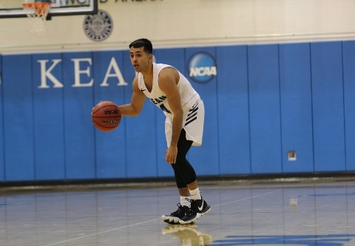
Coach Info:
Position: Junior Varsity
Email: kpacheco@whrhs.org
Favorite Quote: “The world ain’t all sunshine and rainbows. It is a very mean and nasty place and it will beat you to your knees and keep you there permanently if you let it. You, me, or nobody is gonna hit as hard as life. But it ain’t how hard you hit; it’s about how hard you can get hit, and keep moving forward. How much you can take, and keep moving forward. That’s how winning is done.” – Rocky Balboa

Kevin Pacheco is from Bound Brook and came to Watchung Hills where he spent one year before transferring back to Bound Brook. After playing two years of varsity basketball, Pacheco continued his playing career at Penn State University-Abington where he played for head coach Jon Tanous and earned a starting position midway through the season. After a year at Abington, he transferred and played three years at Kean University under head coaches Rob Kurzinsky and Adam Hutchinson. Pacheco was a 2x National Association of Basketball Coaches Honors Court member and represented the men’s basketball team on the Student Advisory Committee (SAC). After concluding his playing career, he began spending his summers coaching with the Watchung Hills boys’ basketball program under the guidance of Coach Salton and Coach Liu.

Pacheco has taken philosophies and strategies from all of his coaches at each stop throughout his playing career and molded them into his own. He emphasizes the work done behind the scenes, individually and collectively, that is necessary to be successful as it was something he prided himself on during his playing career. A basketball lifer, Pacheco hopes to bring his knowledge and background of the game to assist in the development of the Watchung Hills Boys’ basketball family.

Pacheco is currently a School Counselor in the Manville School District.

